Project Design Phase-II TechnologyStack(Architecture&Stack)

Date | 19February2026
Team ID | LTVIP2026TMIDS66458
ProjectName | GeminiHistoricalArtifactDescription
MaximumMarks | 4 Marks

TechnicalArchitecture:
TheDeliverableshallincludethearchitecturaldiagramasbelowandtheinformationasperthetable1&table2

Example:
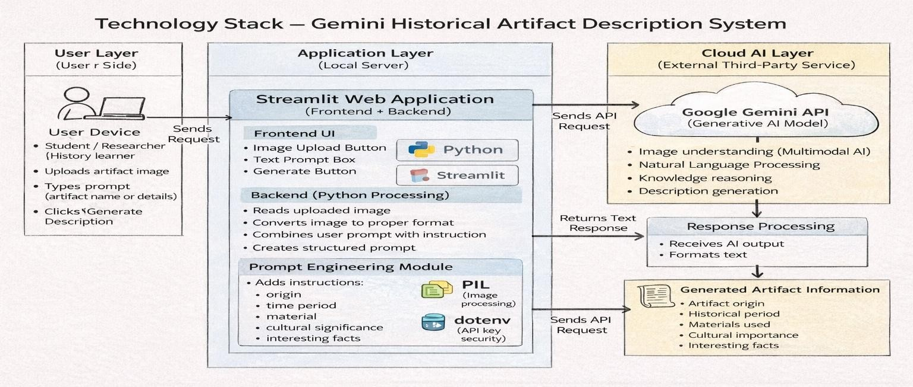

Guidelines:

Includeallmaincomponents:
Showeverypartofthesystem:User(student),WebApplication(Streamlit),Backend(Python),andAImodel (Gemini API).

SeparateLocalandCloudclearly:
  - Local→Streamlitapp+Pythonprocessing(your laptop/server)
  - Cloud→GoogleGeminiAI(external service)

ShowexternalAPIconnection:
Drawanarrowfrom yourapplicationtotheGemini APItorepresentsendingimage+textprompt andreceiving generated description.

Showdataflow direction:
Usearrowstoexplaintheprocess:
UploadImage→Processing→AIModel→Response→Display Result.

Includedatastorage(if used):
Mentionwheretemporaryimages,prompts,orresultsarestored(localmemory/sessionstate).

MentionAImodelusage:
ClearlyindicatethesystemcommunicateswithaMachineLearningmodel(Gemini)for:
  - image understanding
  - naturallanguagegeneration

Explaininputand output:
  - Input→artifactimage+usertextprompt
  - Output→historicaldescription(origin,period,materials,facts)

Keepdiagramsimple:
DoNOTdrawtoomanyboxes.Onlyimportant blocks:
User→WebApp→PythonProcessing→GeminiAPI→ Result

Table-1:Components& Technologies:

S.No | Component | Description | Technology
1. | User Interface | User uploads artifact image and enters prompt through web page. | StreamlitWebUI(Python),HTML, CSS.
2. | ApplicationLogic-1 | Handlesimageupload,validation,andpreprocessing. | Python(Streamlit+PIL library).
3. | ApplicationLogic-2 | Converts image intosuitable format and prepares input prompt. | PythonImageProcessing&Prompt Engineering.
4. | ApplicationLogic-3 | SendsrequesttoAImodelandreceivesgenerated description. | GoogleGenerativeAISDK(Gemini API).
5. | Database | Temporarystorageofsessiondataandprompts. | StreamlitSessionState/LocalMemory (No permanent DB used).
6. | CloudDatabase | Not required — system generates response dynamically. | Not Applicable (Real-time AI response).
7. | FileStorage | Storesuploadedartifactimagestemporarily. | Local File System / RAM (Temporary Storage).
8. | ExternalAPI-1 | AImodelusedtogenerateartifactdescription. | GoogleGeminiProVisionAPI.

9. | ExternalAPI-2 | APIkeyauthenticationandrequesthandling. | GoogleAIStudioAPIKeyService.
10. | MachineLearningModel | Understandsartifactimageandgenerateshistorical explanation. | GeminiMultimodalGenerativeAI Model.
11. | Infrastructure(Server/Cloud) | ApplicationrunslocallyandconnectstocloudAI service. | Local System (Python environment) + Google Cloud AI Service.

Table-2:ApplicationCharacteristics:

S.No | Characteristics | Description | Technology
1. | Open-SourceFrameworks | Theapplicationisdevelopedusingopen-sourcePython libraries for UI, image handling, and API communication. It allows easy development and modification without license cost. | Python, Streamlit, Pillow (PIL), Requests, dotenv.
2. | SecurityImplementations | The system protects API access using a private API keystoredinenvironmentvariables.Onlyauthorized requests are allowed to communicate with the AI model. User data is not permanently stored. | GoogleAPIKeyAuthentication,  .env file, HTTPS secure connection.
3. | ScalableArchitecture | The application follows a lightweight client- serverarchitecture.Thefrontend(StreamlitUI) runslocallywhileheavyprocessingishandled bythecloud-basedGeminiAImodel,allowing multiple users without heavy local hardware. | Google APIKey Authentication, .envfile, HTTPS secure connection.
4. | Availability | The AI service runs on Google Cloud infrastructure, so the system remains available whenever internet connection exists. No local server dependency for AI computation. | Google Cloud AI Services (High Availability Cloud Servers).

